**Registration No: Sp22-Bcs-027 && Sp22-Bcs-051**

**Name: Zeeshan Zafar && Arham Atique**

**Project Description:**

We are making a desktop application for our business “Shahi Carpets”. Making an inventory system to make things easy to manage for ourselves. This application will allow the admin to add, delete, search, and update data regarding carpets. It will also show the current stock available. Using the concepts of File Handling, Serialization, and GUI we are making an interacting application to the best of our ability. We will try our best to complete the above-mentioned things and if we are left with time, will add more to it.

**The Project screenshots:**

1st one is Login page,2nd one in sign Up page and after login The 3rd one is home screen of project and remaining its functions.

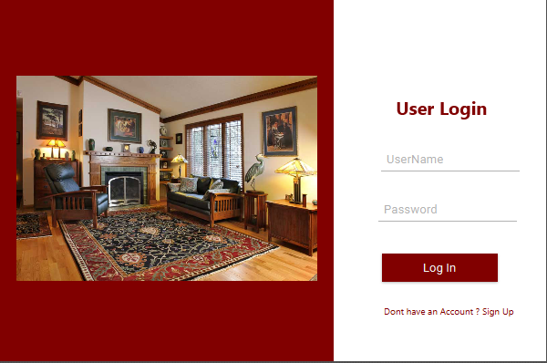

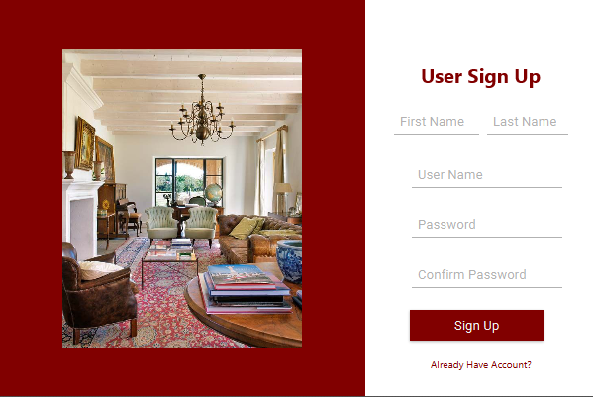



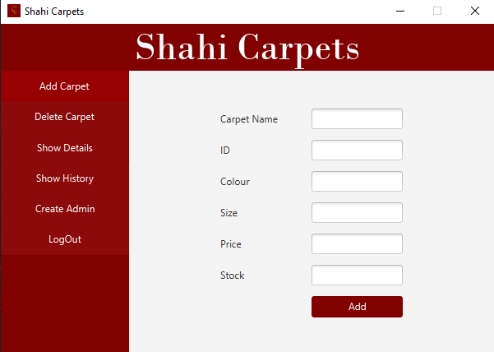

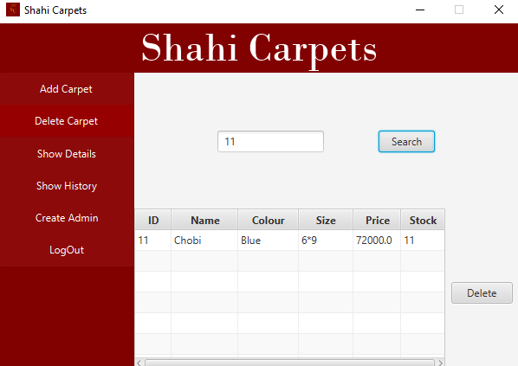

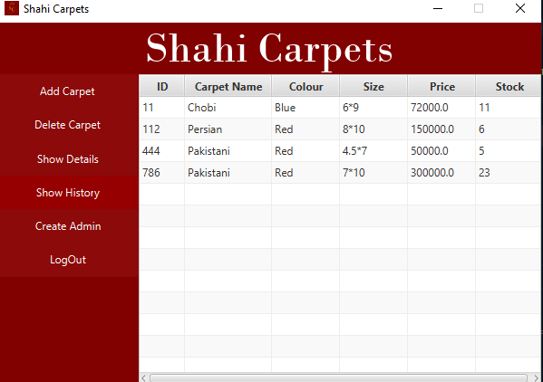

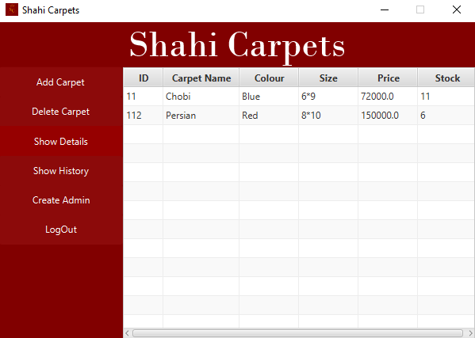

**Code:**

Here is a part of our Code which has been written to develop our program.

package com.example.oopproject;  
  
import javafx.event.ActionEvent;  
import javafx.fxml.FXMLLoader;  
import javafx.scene.Scene;  
import javafx.scene.control.Button;  
  
import java.io.IOException;  
import java.util.ArrayList;  
  
public class UserController {  
  
  
 public Button UserAddButton;  
 public Button UserDeleteButton;  
 public Button UserShowDetails;  
 public Button UserLogOut;  
 public Button ShowHistoryButton;  
 public Button SignUp;  
  
 public void UserAddButtonOnAction(ActionEvent event) {  
  
 try {  
 FXMLLoader fxmlLoader2 = new FXMLLoader(LoginController.class.getResource("AddCarpet.fxml"));  
 Scene scene2 = new Scene(fxmlLoader2.load(), 600, 400);  
 HelloApplication.*stage1*.setScene(scene2);  
 } catch (IOException e) {  
 throw new RuntimeException(e);  
 }  
  
 }  
  
 public void UserDeleteButtonOnAction(ActionEvent event) {  
 try {  
 FXMLLoader fxmlLoader2 = new FXMLLoader(LoginController.class.getResource("DeleteCarpet.fxml"));  
 Scene scene2 = new Scene(fxmlLoader2.load(), 600, 400);  
 HelloApplication.*stage1*.setScene(scene2);  
 } catch (IOException e) {  
 throw new RuntimeException(e);  
 }  
  
 }  
  
 public void UserShowDetailsOnAction(ActionEvent event) {  
 try {  
 FXMLLoader fxmlLoader2 = new FXMLLoader(LoginController.class.getResource("ShowDetail.fxml"));  
 Scene scene2 = new Scene(fxmlLoader2.load(), 600, 400);  
 HelloApplication.*stage1*.setScene(scene2);  
 } catch (IOException e) {  
 throw new RuntimeException(e);  
 }  
  
 }  
  
 public void UserShowHistory(ActionEvent event){  
 ShowHistoryButton.setStyle("-fx-background-color: #960000; ");  
  
 try {  
 FXMLLoader fxmlLoader2 = new FXMLLoader(LoginController.class.getResource("ShowHistory.fxml"));  
 Scene scene2 = new Scene(fxmlLoader2.load(), 600, 400);  
 HelloApplication.*stage1*.setScene(scene2);  
  
 } catch (IOException e) {  
 throw new RuntimeException(e);  
 }  
 }  
  
 public void UserLogOutOnAction(ActionEvent event) {  
 UserLogOut.setStyle("-fx-background-color: #960000; ");  
  
 try {  
 if (Boxes.*confirmBox*("Logout", "Do you want to log out?")) {  
 FXMLLoader fxmlLoader2 = new FXMLLoader(LoginController.class.getResource("Login.fxml"));  
 Scene scene2 = new Scene(fxmlLoader2.load(), 600, 400);  
 HelloApplication.*stage1*.setScene(scene2);  
 }  
 } catch (IOException e) {  
 throw new RuntimeException(e);  
 }  
  
 }  
  
  
 public void CreateAdminOnAction(ActionEvent event) {  
  
 try {  
 FXMLLoader fxmlLoader2 = new FXMLLoader(SignUpController.class.getResource("SignUp.fxml"));  
 Scene scene2 = new Scene(fxmlLoader2.load(), 600, 400);  
 HelloApplication.*stage1*.setScene(scene2);  
  
 } catch (IOException e) {  
 throw new RuntimeException(e);  
 }  
  
 }  
  
  
  
  
  
}